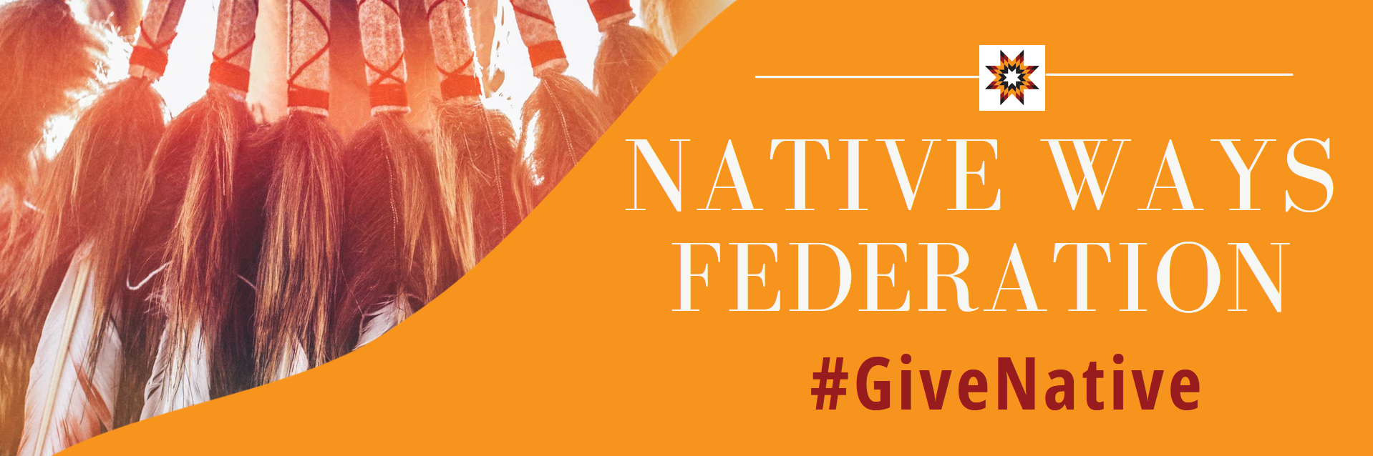
Worksheet: Quick Plan to Build Your Giving Tuesday Campaign
There are dozens of resources for organizations on how to start a Giving Tuesday campaign. We have identified a few key steps and questions that are intended to help you start your planning. You may find that you need adjustments for this document to work best for you and your organization. The #GiveNative Campaign Workshop (link available shortly) has more details and descriptions of the steps and questions below.
☐ Sign up for the #GiveNative Campaign
Click here to open the form
☐ What other cause- and location-based campaigns are related to your work?
Click here to find a map of location-based campaigns and a list of cause campaigns nation-wide (these lists do not include all existing campaigns)

☐ Identify Purpose and Goals
What do you hope to accomplish through your campaign?
Are there specific goals you want to reach? Are you seeking support for a specific program or initiative?

How will you use #GiveNative alongside your Giving Tuesday campaign or end of year fundraising efforts?

☐ Prepare Your Stories and Activities
What do you want people to know about your work? What are you doing that’s specific to your community?
(GivingTuesday Tip for Great Campaigns: Relevance, Authenticity, Urgency, Creativity)

How can people give to your organization?
Time, Money, Things (food, clothing, etc.)

How will you engage your community?
What activation (in-person or online activity or event) will you host? How will you start a conversation? How will you motivate your supporters to share their stories of generosity?

Who can you ask to help spread your stories?
Native and non-Native – community members, leaders, businesses, organizations, elected officials, tribes, influencers, news media, etc.

☐ Launch!
Share your story and engage your audience!
Use #GiveNative and our pre-designed materials whether you launch on, before, or after Giving Tuesday.

☐ Reflect
Looking back at your goals – how did you do?

What worked well? What are you excited to continue doing next year?

What did not work well? What would you do differently next year to build on what you accomplished this year?

